**Project Design Phase-II**

**Technology Stack (Architecture & Stack)**

|  |  |
| --- | --- |
| Date |  |
| Team ID | LTVIP2025TMID42361 |
| Project Name | Househunt: Finding Your Perfect Rental  Home |
| Marks |  |

**Technical Architecture:**

The Deliverable shall include the architectural diagram as below and the information as per the table1 & table 2

**Example: Order processing during pandemics for offline mode**

**Reference:** [**https://developer.ibm.com/patterns/ai-powered-backend-system-for-order-processing-during-pandemics/**](https://developer.ibm.com/patterns/ai-powered-backend-system-for-order-processing-during-pandemics/)

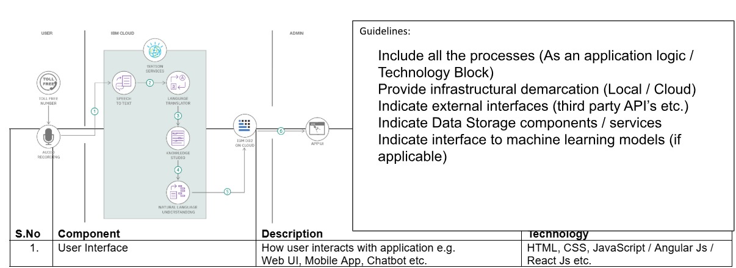

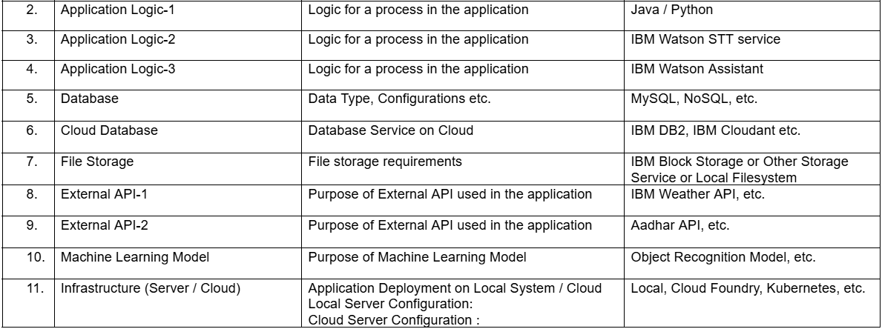

Table-2: Application Characteristics:

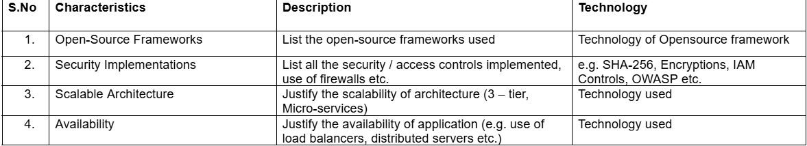

**References:**

[**https://c4model.com/**](https://c4model.com/)

[**https://developer.ibm.com/patterns/online-order-processing-system-during-pandemic/**](https://developer.ibm.com/patterns/online-order-processing-system-during-pandemic/)

[**https://www.ibm.com/cloud/architecture**](https://www.ibm.com/cloud/architecture)

[**https://aws.amazon.com/architecture**](https://aws.amazon.com/architecture)

[**https://medium.com/the-internal-startup/how-to-draw-useful-technical-architecture-diagrams-2d20c9fda90d**](https://medium.com/the-internal-startup/how-to-draw-useful-technical-architecture-diagrams-2d20c9fda90d)